DOCUMENT OBJECT MODEL (DOM)

1. What is the DOM?
- The Document Object Model (DOM) is a programming interface for HTML documents.
- It represents the page as a tree structure where everything is a node.
- JavaScript uses the DOM to read, modify, add, or delete elements on a webpage.

2. Types of DOM Nodes
- Document Node
  - Represents the entire HTML document.
  - Root of the DOM tree.
  - nodeName = "#document"
- Element Nodes
  - Represent HTML tags (e.g., <html>, <body>, <p>).
  - nodeName = tag name (e.g., "P", "DIV").
- Text Nodes
  - Store the actual text inside elements.
  - Always have the node name #text.
- Attribute Nodes
  - Represent HTML attributes (e.g., id, class).
  - nodeName = attribute name.
- Comment Nodes
  - Represent HTML comments <!-- comment -->.

3. Parent–Child Relationship (DOM Tree Example)
Sample HTML:
<html>
<head>
<title>DOM Tutorial</title>
</head>
<body>
<h1>DOM Lesson one</h1>
<p>Hello <span>world</span></p>
</body>
</html>
Tree Structure Breakdown
- document node
  - <html> (child of document)
    - <head>
      - <title>
        - Text Node: "DOM Tutorial"
    - <body>
      - <h1>
        - Text Node: "DOM Lesson one"
      - <p>
        - Text Node: "Hello "
        - <span>
          - Text Node: "world"
Important:
Text is never directly inside an element node.
It is always stored inside a text node.

4. Text Nodes — Very Important Concept
- A common mistake is to think:
- <title>DOM Tutorial</title>
that "DOM Tutorial" is part of <title> element.
- Actually:
  - <title> is an element node
  - "DOM Tutorial" is a text node inside it.
- In JavaScript, we often use:
- title.innerHTML
to read the text content of the text node.

5. Key DOM Properties
Property | Meaning
x.innerHTML | Text/HTML contained inside node x
x.nodeName | Name of the node (e.g., DIV, #text)
x.nodeValue | Value of the node (mainly text or attribute value)
x.parentNode | Parent of node x
x.childNodes | All children of node x (elements + text nodes)
x.attributes | Attribute nodes of element x
Note: x refers to any DOM node.

6. Key DOM Methods
Method | Description
x.getElementById(id) | Selects one element by id
x.getElementsByTagName(name) | Returns all elements of a particular tag
x.appendChild(node) | Adds a node as the last child of x
x.removeChild(node) | Removes a child node from x

7. nodeName Property
- Read-only
- Values based on node type:
  - Element Node → tag name ("P", "BODY")
  - Attribute Node → attribute name ("class")
  - Text Node → #text
  - Document Node → #document

8. nodeType Property (for quick identification)
Node Type | Meaning
1 | Element Node
2 | Attribute Node
3 | Text Node
8 | Comment Node
9 | Document Node

Final Summary
- The DOM represents HTML as a tree of nodes.
- Nodes include document, element, text, attribute, and comment nodes.
- Text inside elements is always stored in text nodes, not in the element itself.
- DOM properties and methods allow JavaScript to interact with the webpage dynamically.
- nodeName and nodeType help identify node types during DOM manipulation.

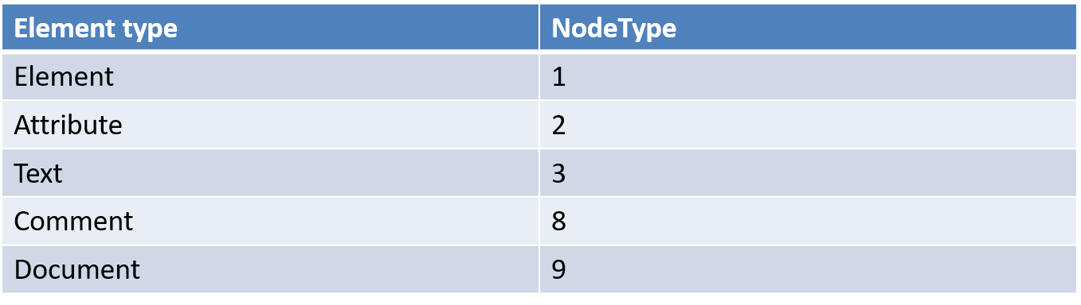

DOM + JavaScript Events + classList + Selectors + Timers — COMPLETE NOTES

1. getElementById() — DOM Node Access
let s = document.getElementById("pr");
- Returns: Object of type HTML element (ParagraphElement, DivElement, etc.)
- Key properties used:
  - s.nodeName → Tag name (e.g., "P")
  - s.childNodes → List of child nodes (text + element nodes)
  - s.childNodes[0].nodeValue → Text inside 1st child text node
  - s.childNodes[0].nodeName → #text
  - s.childNodes[0].nodeType → 3 (Text Node)
  - s.innerHTML → Complete HTML inside the tag
Example:
<p id="pr">Welcome<b> to world of</b> Dom</p>
alert(s.childNodes[1].childNodes[0].nodeValue);
// returns " to world of"
nodeValue
[welcome]
0
#text
<b>
#text-3

1

nodeValue
[DOM]
#text
2

2. Copy Text Between Elements
y.innerHTML = x.innerHTML
y.innerHTML = x.innertext //Doesn’t appy tag effect

3. Task: Create <div> and copy text to <h1> on mouseover
- On mouseover → copy content of div
- Place copied text inside <h1>
(Practice exercise)
<body>
<script>
function call(){
var x = document.getElementById('d')
var y = document.getElementById('h')
y.innerHTML = x.innerHTML
}

</script>

<div id="d">
Girish Sanjay Borade
</div>

<input type="button" value="copy" onclick="call()">

<h1 id="h"></h1>
</body>

4. Read value “bye” from
<p id="pp"> hello<b>bye</b></p>
Use:
document.getElementById("pp").childNodes[1].childNodes[0].nodeValue

5. getElementsByTagName()
- Returns HTMLCollection (array-like object).
<head>
<script type="text/javascript">
function callme() {

let s = document.getElementsByTagName("p"); // Get all <p> tags → returns array-like HTMLCollection
let l = s.length; // Total number of <p> tags
textdata = ""; // Variable to store combined text of all <p> tags
for (i = 0; i < l; i++) {
textdata += s[i].innerHTML + "<br>"; // Also store all text in a variable (optional usage)
}
}
</script>
</head>

<body>
<!-- Button to run function -->
<input type="button" onclick="callme()" value="clickme" />

<!-- Sample <p> tags -->
<p>Welcome<b> to world of</b>Dom</p>
<p>2nd p</p>
<p>3rd p</p>

<!-- Output area -->
<div id="dd"></div>
</body>

Task: Read 5 <p> tags and display in <div>.

6. document.write() & Order of Execution
If script runs before the <p> tags:
document.write(s[i].innerHTML) // p tags not yet loaded!

Because execution is top-to-bottom.

7. Reading TextBox Value
let a = document.getElementById("nm1");
let b = document.getElementById("nm2");
b.value = a.value;

8. Checkbox Task
- Create 2 textarea + 1 checkbox
- On checkbox click → copy address from textarea1 → textarea2

9. Practice Questions

10. classList Property
Used to read, add, remove, toggle, and replace CSS classes.
Access:
var x = document.getElementById("myDIV").classList;
Properties:
- x.length
- x[0], x[1], etc.

11. getElementsByClassName()
var list = document.getElementsByClassName("example");
list[0].getElementsByClassName("child")[0].innerHTML = "Milk";

- Returns HTMLCollection
- child accessed inside each list

12. classList.add()
document.getElementById("myDIV").classList.add("anotherClass");

Adds CSS class dynamically.

13. Better Way (Store object once)
let divobj = document.getElementById("myDIV");
let y = divobj.classList;
y.add("anotherClass");

14. classList.remove()
document.getElementById("myDIV").classList.remove("anotherClass");

15. classList.replace()
document.getElementById("myDIV").classList.replace("anotherClass", "myClass");

16. Radio Button Task
- Create 3 radio buttons → Red, Green, Blue
- On click → change color of paragraph

17. classList.contains()
arr.contains("anotherClass"); // true / false

18. classList.toggle()
document.getElementById("myDIV").classList.toggle("anotherClass");

- If present → removes
- If not present → adds
- Returns boolean

19. querySelector() & querySelectorAll()
Inside a div:
var x = document.getElementById("myDIV").querySelectorAll("p");
x[0].style.backgroundColor = "red";
Differences:
- querySelectorAll("p") → Selects all p tags
- querySelector("p") → Selects first matching p
Examples:
document.querySelector("#foobar");
document.querySelector(".myclass");
document.querySelector("div.user-panel.main input[name='login']");

20. setAttribute() and getAttribute()
document.getElementById("pp").setAttribute("align", "left");
document.getElementById("dd").innerHTML =
document.getElementById("pp").getAttribute("align");

21. Timers: setTimeout()
setTimeout("timedCount()", 1000);
Better way:
setTimeout(sayHi, 1000);
setTimeout(() => alert("Hello"), 1000);
Example Counter:
c = 0;
t = setTimeout("timedCount()", 1000);
clearTimeout(t); // Stop timer

22. setInterval()
Runs repeatedly until stopped.
t = setInterval("call()", 1000);
clearInterval(t);
Warning:
setInterval("call()",1000) will rapidly increase number if misused.

23. Changing Style Dynamically
document.getElementById("pr").style.color = "red";
document.getElementById("pr").style.background = "yellow";
Reset on mouseout:
document.getElementById("pr").style.color = "black";

24. Setting class Dynamically (className)
ob = document.getElementById("pr");
ob.className = "cl";
Replaces existing class.

25. Working with Images
- All images available as:
document.images
- Access by name or id:
document.mg.src = "b.bmp";
document.getElementById("im").src = "b.bmp";
Mouse events:
<img id="im" onmouseover="callme()" onmouseout="backimg()">

